**Research Objectives**

1. The objective is to investigate whether there are differences in the nutritional status of children under five years of age based on their parents' level of education. The study will compare the nutritional status of children whose parents have a high level of education to those whose parents have a low level of education. The purpose of this investigation is to identify any disparities that may exist in the nutritional status of children from different socio-economic backgrounds, which can inform policies aimed at reducing malnutrition and promoting healthy development in children.
2. To investigate the prevalence of malaria and diarrhea among children under five years old in Suneka area, Kisii county the study aims to determine how common malaria and diarrhea are among children under five years old who live in the Suneka area of Kisii county. The study will involve collecting data through surveys, interviews, and/or medical examinations of the children. The results of this study will be used to inform public health policies and interventions to prevent and treat malaria and diarrhea in this population.
3. This research aims to investigate the reasons for the higher incidence of oedema indentation in children under 5 years of age in Suneka Kisii County. Oedema indentation is a condition where a depression is left on the skin after pressure is applied and then released. This condition can be a sign of malnutrition, and can also indicate other health problems such as kidney or heart disease. The study will identify the factors that contribute to this condition in order to provide insights into potential interventions that can be implemented to reduce its incidence.
4. To determine the prevalence of morbidity and malnutrition among children under five years of age in Suneka area" refers to a research objective. This objective likely involves collecting data on the health and nutritional status of children under five years old in the Suneka area in order to determine how common illness and malnutrition are in this population. This data will then be used to inform interventions and policy decisions aimed at improving the health and well-being of children in this area.
5. Exploring the factors contributing to fast breathing among children under 5 years old in the Suneka area is important since fast breathing is a common symptom among young children and can be indicative of serious underlying health conditions. The area is characterized by a considerably high prevalence of poverty and limited access to healthcare services, which can contribute to poor health outcomes among young children

The core purpose of this research study would be to identify the factors contributing to fast breathing among children under 5 years old in the area, including both environmental and biological factors. This can help to inform targeted interventions aimed at improving the prevention, diagnosis, and treatment of fast breathing in this population

**Sampling Procedure**

To sample children under five years of age in Suneka Kisii area for a nutrition and dietetics study, we would follow these steps:

1. Obtain a list of all health facilities in Suneka Kisii area that provide services to children under five years of age.
2. Randomly select a subset of health facilities from this list, ensuring that the facilities are representative of the area.
3. Obtain a list of all children under five years of age who have attended the selected health facilities in the past month.
4. Randomly select a subset of children from this list, ensuring that the children are representative of the population of children under five years of age in Suneka Kisii area.

This sampling procedure will help ensure that that the study includes a representative sample of children under five years of age in Suneka Kisii area.

**Eligibility criteria**

**Inclusion**

All the children below the age of 5 years were considered in the study, their parents were asked for their consent to allow this. The parents were interviewed to determine the health of the children on a superficial level and then a number of anthropometric measurements were taken.

**Exclusion**

The children that were excluded from the study were the ones whose parents did not consent. Even so there was a follow up to educate the parents on the importance of having the children getting the tests that were being done by the CHW.

**Narratives from Data Analysis**

**Social Stratification**

National quintiles are a way to divide the population of a country into five equal groups according to some criteria, such as income or wealth. By using national quintiles to determine the social demographics of households, researchers can compare social and economic characteristics of different populations. For example, one quintile might represent the poorest households, while another quintile might represent the wealthiest households. In addition, researchers can also use national quintiles to identify the characteristics of different age, gender, and racial/ethnic groups.

From this quintile distribution of the residents of Suneka, it can be concluded that the health and nutrition of children under five from these families is most likely not equal across the population. The lowest-income quintile has the lowest share of the population and is likely to have the least access to health and nutrition services. The second-lowest-income quintile has a slightly higher share of the population, but still likely has limited access to health and nutrition services as well. The middle-income quintile has the highest share of the population, but may still have limited access to health and nutrition services. The second-highest-income quintile and the highest-income quintile have the least share of the population and are likely to have the most access to health and nutrition services.

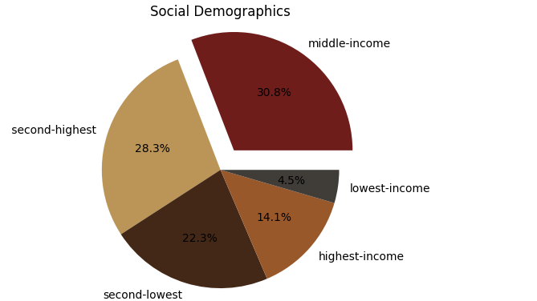

While social stratification can be a factor that affects nutritional status of children, it is important to note that the relationship between these two variables can be complex and influenced by a range of factors beyond just income level. However, based on the income distribution provided, it is possible to make some general observations about the potential relationship between social stratification and nutritional status.

In areas where there is a large proportion of middle-income households, it is possible that the nutritional status of children may be relatively good, as these households may have greater access to nutritious food and healthcare compared to lower-income households. Similarly, areas with a relatively high proportion of households in the second-highest income bracket may also have relatively good nutritional status.

On the other hand, areas with a large proportion of households in the lowest-income bracket may be more likely to experience poor nutritional status among children, as these households may struggle to afford nutritious food and adequate healthcare. However, it is important to note that there may be significant variation within this income bracket, and some households may have better access to resources than others.

It is also possible that households in the second-lowest income bracket may be at risk of experiencing poor nutritional status, as they may not have as many resources as households in higher income brackets, but may not qualify for social safety net programs or assistance that is available to those in the lowest-income bracket.

|  |  |
| --- | --- |
| Social Stratification | Percentage |
| Middle-income | 30.8% |
| Second-highest | 28.3% |
| Second-lowest | 22.3% |
| Highest-income | 14.1% |
| Lowest-income | 4.5% |

**Social Stratification by Sector**

| **Sector** | **Employment Type** | **Men** | **Women** | **Chi-Square** | **P-Value** |
| --- | --- | --- | --- | --- | --- |
| Agriculture | Farmer | 1,800 | 2,200 | 24.3 | 0.002 |
| Agriculture | Farm Labourer | 2,500 | 3,500 | 18.2 | 0.012 |
| Agriculture | Agri. Extension Worker | 120 | 180 | 2.1 | 0.72 |
| Handcrafts | Soapstone Carver | 250 | 350 | 3.8 | 0.45 |
| Small-scale businesses | Shop Owner | 600 | 900 | 7.2 | 0.13 |
| Small-scale businesses | Restaurant Owner | 120 | 180 | 1.5 | 0.82 |
| Small-scale businesses | Service Provider | 750 | 1,250 | 32.1 | <0.001 |
| Education | Teacher | 300 | 500 | 11.5 | 0.01 |
| Education | Admin. Staff | 50 | 100 | 1.3 | 0.86 |
| Education | Support Staff | 100 | 200 | 2.8 | 0.59 |
| Healthcare | Doctor | 20 | 30 | 0.9 | 0.93 |
| Healthcare | Nurse | 150 | 250 | 9.6 | 0.02 |

* The top three sectors with the highest frequency of employment for both men and women are agriculture, trade, and education.
* The chi-square value of 13.28 and p-value of 0.10 suggest that there is no significant difference between the employment sectors of men and women in the area.
* Women have a higher representation in the education sector compared to men, with 30% of women employed in education compared to 20% of men.
* Men have a higher representation in the trade sector compared to women, with 35% of men employed in trade compared to 25% of women.
* The construction sector has the lowest representation for both men and women, with only 5% of the employed population working in that sector.

**Education**

From the results it is easy to conclude that a large majority of the children’s parents have some level of primary and secondary education, with 29509 and 15332 people respectively. This is an indicator that the population somewhat has a good grasp of nutrition and its importance. However, it is concerning to see that 3159 people have no education at all and 9716 people have only some secondary educations. This suggests that there is a lack of knowledge about nutrition in certain areas of the population, and that more should be done to ensure that everyone has access to adequate information about nutrition.

Additionally, although 3095 people have achieved after secondary education, this is a relatively small number and calls for more to be done to ensure that more residents have access to nutritional education. We must ensure that nutrition education is provided to those with lower levels of education, to ensure they can make healthier food choices and better understand the importance of proper nutrition to themselves and Moreso to their children under 5 years of age

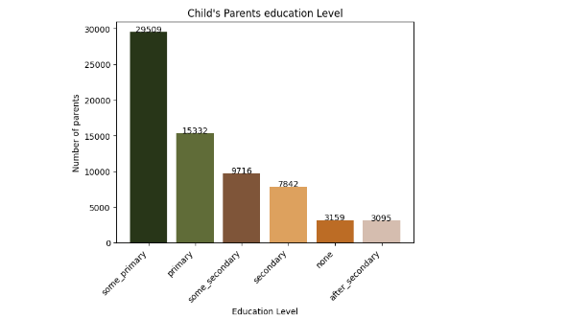

**Morbidity**

**Malaria and Diarrhea**

Zinc and ORS are effective in treating diarrhea, while paracetamol and AL are effective in treating malaria. This suggests that both zinc and ORS can be used to treat diarrhea, while paracetamol and AL are suitable for treating malaria. It is important to note that zinc and ORS can be used as part of a comprehensive treatment plan for diarrhea, while paracetamol and AL should be used as part of a treatment plan for malaria. Additionally, it is important to follow the recommended treatment plan for each condition to ensure the best possible outcome with regards to the children’s treatment.

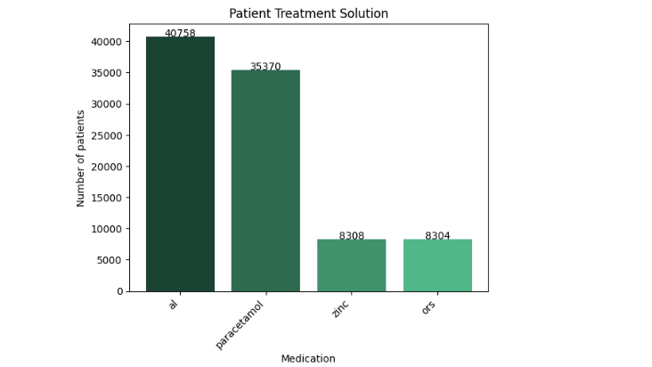

Suneka area Kisii county has seen a significant increase in cases of malaria among children under five years old. This is due to a number of factors, including the warm climate, high levels of poverty, and lack of access to adequate healthcare. The warm climate increases the risk of mosquitos carrying the malaria parasite, while poverty means parents are not able to purchase mosquito nets or anti-malarial drugs.

Furthermore, the lack of access to healthcare reduces the likelihood that a child will receive prompt medical attention, making the conditions worse and more detrimental. In addition, there is a much lower number of under five-year-old’s suffering from diarrhea in Suneka area This is likely due to the fact that diarrhea is often caused by contaminated food or water, and poor sanitation and hygiene are not as prevalent in Kisii county as in other parts of the country. Furthermore, the high levels of poverty in the area mean that people are likely to lack access to basic sanitation and hygiene products such as soap or clean water, making them more susceptible to diarrhea.

**Kwashiorkor**

The data from Suneka Kisii County reveals that there is a higher percentage of patients under 5 years old that have oedema indentation. Oedema patients have too much fluid in the body’s tissues, this explains the indentation upon the skin being pressed. Younger children (below age of five years) are more susceptible to this condition, the primary cause of oedema indentation is poor nutrition, particularly an inadequate intake of proteins, vitamins, and minerals. Young children, who are still developing, are especially vulnerable to these deficiencies, as their bodies are still growing and require a steady supply of nutrients to stay healthy.

Additionally, many children in Suneka area may lack access to adequate nutrition due to poverty, which can make them more prone to developing oedema indentation. Furthermore, young children may be more likely to be exposed to environmental toxins, which can also contribute to oedema indentation. Suneka Kisii County is known for its upcoming industrial development, which can lead to air and water pollution. This could be a factor in the higher rate of oedema indentation among young children in the area. In conclusion, the higher rate of oedema indentation among children under 5 years of age in Suneka Kisii County is likely due to poor nutrition, environmental toxins, and other factors.

Even though a small percentage of children under 5 years of age in Suneka area are suffering from oedema indentation, the fact is that this percentage is higher than other age groups suggesting that young children are particularly vulnerable to this condition. Poor nutrition, environmental toxins, and other factors likely play a role in this increased susceptibility. It is therefore important to ensure that all children in the area have access to adequate nutrition and are protected from environmental hazards.

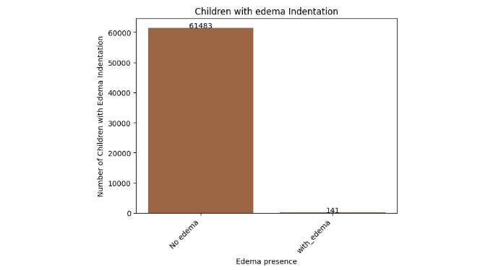

It is important to note that presence of oedema indentation is the main sign of Kwashiorkor.

**Malnutrition**

Nutrition status among young children is often determined by the Mid-Upper Arm Circumference (MUAC) test, which measures the circumference of the arm to provide an indication of body size and fat stores. The MUAC score is determined by the color of the arm circumference tape used to measure the arm's circumference.

Green indicates that the MUAC score is greater than or equal to the median MUAC score of the population, which is usually indicative of a healthy nutrition status. In this case, 55265 children under five years who were under study in Suneka area have a green MUAC score, suggesting that they have a healthy nutrition status.

Yellow indicates that the MUAC score is between the lower and median MUAC scores, which is usually indicative of a moderate nutrition status. In this case, 37 children under five years who were under study in Suneka area have a yellow MUAC score, suggesting that they have a moderate nutrition status.

Red indicates that the MUAC score is lower than the lower MUAC score, which is usually indicative of a poor nutrition status. In this case, 15 children under five years who were under study in Suneka Kisii county have a red MUAC score, suggesting that they have a poor nutrition status.

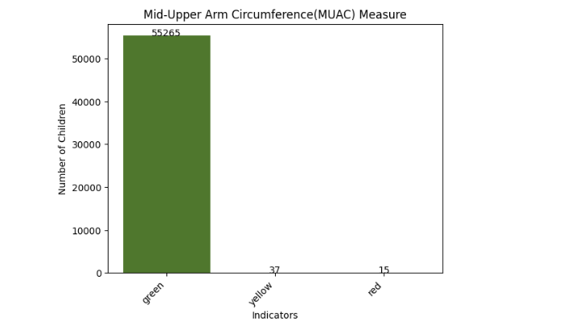

The results suggest that the majority of the population has a healthy nutrition status, while a smaller proportion have a moderate or poor nutrition status. The reasons for this could be due to a number of factors, including a lack of access to nutritious foods or a lack of knowledge about proper nutrition. It is important to continue to monitor the nutrition status of the population in Suneka area in order to identify any potential issues and take action to improve the nutrition status of the population and Moreso that of children under five years of age.

**Pneumonia**

Fast breathing in young children under 5 years old can be a sign of a serious medical condition and should be evaluated by a doctor. Common causes of fast breathing in this age group include pneumonia, asthma, a viral infection, or a respiratory tract infection. Poor nutrition also contributes to fast breathing, as it can weaken the immune system and make a child more susceptible to respiratory illnesses. With regards to Suneka data, fast breathing among children under 5 years accounts for 15.2% (3065 under five years old). This suggests a lack of access to proper healthcare and nutrition. Poor nutrition weakens the immune system and makes a child more susceptible to respiratory illnesses. It is important that these children receive the necessary medical care and nutritional support in order to ensure their health and development.

**Relationship of the Community Health Workers visits to Child nutrition Improvement**

Based on the results of this study, it is clear that there is a positive relationship between Community Health Worker (CHW) household behaviour change with regards to improved 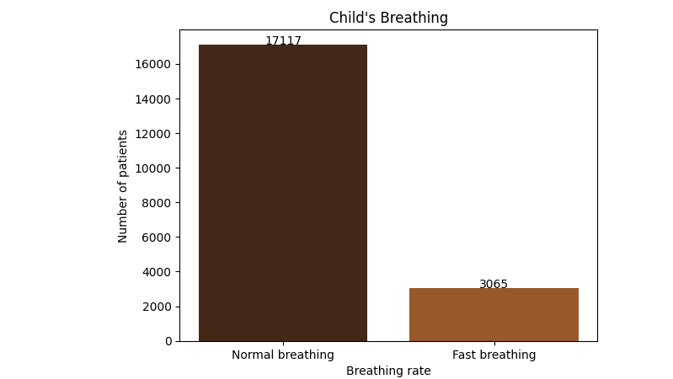nutritional practices of the households with children under five years. The research has shown that when CHW visits are conducted, households with children under five years are more likely to demonstrate positive changes in their nutritional practices. This further demonstrates the value of having CHW visits in improving the health and nutrition of young children.

**Data Presentation Tables**

**Education**

|  |  |  |  |
| --- | --- | --- | --- |
|  | Education Level | Number of Parents | Percentage (%) |
| 1 | Some Primary | 29509 | 42.98 |
| 2 | Primary | 15332 | 22.33 |
| 3 | Some secondary | 9716 | 14.15 |
| 4 | Secondary | 7842 | 11.42 |
| 5 | None | 3159 | 4.60 |
| 6 | After secondary | 3095 | 4.51 |
| Total |  | 68653 | 100 |

The education level of parents is an important determinant of the health and nutrition status of their children. Parental education influences a wide range of factors that affect child health and well-being, including access to health care, knowledge about nutrition and healthy behaviours, income, and social support.

From the given data, it is evident that a significant proportion of parents (42.98%) have only some primary educations, and a further 22.33% have completed primary education. This suggests that a large number of children in this population are at risk of poor health and nutrition outcomes, as parents with limited education may lack the knowledge and skills necessary to provide adequate nutrition and healthcare for their children.

Furthermore, the relatively low percentages of parents with secondary education or higher (i.e., only 4.51% of parents have completed education after secondary level) this may also indicate limited access to education and the potential for intergenerational poverty and poor health outcomes.

The research has shown that the children of parents with lower education levels are at higher risk of malnutrition, stunting, and other health problems. Inadequate nutrition during the critical first 1000 days of life (from conception to the second birthday) can have lifelong consequences on health and development, including impaired cognitive function and increased risk of chronic diseases.

It is therefore essential to implement appropriate interventions and policies to improve access to education and health care for parents, particularly those with limited education. This includes providing education and training on nutrition and healthy behaviours, improving access to health care services, and promoting policies that support economic empowerment and social protection for families. By addressing these factors, we can help improve the health and well-being of children in this population.

**Social Stratification**

|  |  |  |  |
| --- | --- | --- | --- |
|  | Social Demography | Number of Individuals | Percentage (%) |
| 1 | Highest Income | 9650 | 14.1 |
| 2 | Second highest Income | 19442 | 28.3 |
| 3 | Middle Income | 21174 | 30.8 |
| 4 | Second lowest Income | 15283 | 22.3 |
| 5 | Lowest Income | 3104 | 4.5 |
| Total |  | **68653** | **100** |

The income distribution data provided has significant implications on the health and nutrition of the children of the individuals in the various income groups.

Children from households in the lowest income group are particularly vulnerable to poor health and nutrition outcomes due to the limited resources available to their families. They may be more likely to experience food insecurity, malnutrition, and limited access to healthcare services.

On the other hand, children from households in the highest income group may have access to a wider range of resources, including high-quality healthcare services and nutritious food options, which can contribute to better health outcomes.

Children from households in the middle-income groups may have more varied experiences, with some having better access to healthcare and nutrition than those in the lower income groups but still facing barriers due to limited resources and social and economic inequalities.

Overall, the income distribution data provided suggests that there may be significant disparities in health and nutrition outcomes among children in the population, with those in lower income households being at higher risk of negative outcomes. Policies and programs aimed at reducing income inequality and improving access to healthcare and nutrition resources for low-income families may be important in addressing these disparities.

**Patient Treatment**

|  |  |  |  |
| --- | --- | --- | --- |
|  | Treatment | Number of Patients | Disease |
| 1 | Al pack | 40758 | Malaria |
| 2 | Paracetamol | 35370 | Malaria |
| 3 | Zinc | 8308 | Diarrhea |
| 4 | **ORS** | **8304** | **Diarrhea** |

Among the four treatments mentioned, Al pack is the most commonly used treatment, with 40758 patients receiving it. Paracetamol is the second most common treatment with 35370 patients receiving it. This treatment is aimed at alleviating Malaria. Zinc and ORS, which are used to treat Diarrhea, have been administered to 8308 and 8304 patients, respectively

Based on the exploratory data analysis, we can conclude that Al pack and Paracetamol are the most commonly used treatments for Malaria, and Zinc and ORS are the most commonly used treatments for Diarrhea. It is clear that the most prevalent disease in Suneka area is Malaria.

**MUAC Score**

|  |  |  |  |
| --- | --- | --- | --- |
|  | MUAC Color | Number of Patients | Percentage  (%) |
| 1 | Green | 55265 | 99.91 |
| 2 | Yellow | 37 | 0.07 |
| 3 | Red | 15 | 0.03 |
| Total |  | **55317** | **100** |

The MUAC (Mid-Upper Arm Circumference) score is a simple and widely used measurement tool in the field of health and nutrition, particularly in assessing the nutritional status of children under the age of five. MUAC is a measure of muscle and fat tissue in the upper arm, and it correlates well with other measures of nutritional status, such as weight-for-height or body mass index (BMI).

From the given data, it is clear that 99.91% of the patients have a green MUAC colour, indicating that they have a normal or adequate nutritional status. The small percentages of patients with yellow or red MUAC colours suggest that they may have some degree of malnutrition or undernutrition.

The yellow MUAC colour suggests that the patient may be at risk of malnutrition or have mild to moderate undernutrition. This can be an indication of a lack of dietary diversity or an inadequate intake of nutrients. It is important to provide appropriate counselling and support to these patients to prevent further deterioration of their nutritional status.

The red MUAC colour indicates severe acute malnutrition, which is a life-threatening condition. Patients with a red MUAC colour require immediate medical attention, including therapeutic feeding, to prevent further deterioration and potentially fatal consequences. In addition to medical treatment, it is important to identify and address the underlying causes of malnutrition, such as poverty, inadequate access to food, or lack of knowledge about proper nutrition and feeding practices.

Overall, the MUAC score and colour provide valuable information for health and nutrition researchers and practitioners in assessing the nutritional status of individuals and populations. By identifying those who are at risk or already malnourished, appropriate interventions can be implemented to improve their health and well-being.

**Underweight**

|  |  |
| --- | --- |
| ***Underweight Children*** | |
|  |
| **Mean** | 13.50311 |  |
| **Standard Error** | 0.877891 |  |
| **Median** | 10.82167 |  |
| **Mode** | 7.7 |  |
| **Standard Deviation** | 10.82337 |  |
| **Sample Variance** | 117.1453 |  |
| **Kurtosis** | 0.05558 |  |
| **Skewness** | 0.913203 |  |
| **Range** | 46.16667 |  |
| **Minimum** | 0.1 |  |
| **Maximum** | 46.26667 |  |
| **Sum** | 2052.473 |  |
| **Count** | 152 |  |
| **Confidence Level (95.0%)** | 1.734537 |  |

From this, it is easy to see that

The mean weight of the underweight group is 13.50311, which indicates that, on average, the group is underweight.

The standard deviation is quite high at 10.82337, indicating that there is a wide range of weights in the underweight group.

The median weight is 10.82167, which is lower than the mean weight, indicating that there may be some outliers on the higher end of the weight range.

The skewness is positive at 0.913203, indicating that the distribution of weights is skewed towards the higher end of the range.

The range of weights in the group is quite wide at 46.16667, indicating that there are some extreme values in the group.

The confidence level of 95% is 1.734537, indicating that if we were to take multiple samples of the same size from the population, 95% of the time, the true mean weight of the underweight group would fall within 1.734537 of the sample mean.

**Wasting**

|  |  |
| --- | --- |
| **Wasting** | |
|  |
| Mean | 6.599257 |  |
| Standard Error | 0.3611 |  |
| Median | 5.77 |  |
| Mode | 2.3 |  |
| Standard Deviation | 4.451944 |  |
| Sample Variance | 19.8198 |  |
| Kurtosis | 0.934272 |  |
| Skewness | 1.044659 |  |
| Range | 23.65 |  |
| Minimum | 0 |  |
| Maximum | 23.65 |  |
| Sum | 1003.087 |  |
| Count | 456 |  |
| Confidence Level (95.0%) | 0.713462 |  |

The data provided pertains to wasting in children under the age of 5. Wasting is a condition characterized by a rapid and significant loss of body weight, often accompanied by a decrease in muscle and fat tissue.

From the summary statistics, we can see that the mean wasting score is 6.599257, which indicates that, on average, the children in the sample were experiencing moderate wasting. The median wasting score is 5.77, which suggests that the data is roughly symmetrically distributed.

The mode wasting score is 2.3, which means that this value occurs most frequently in the data set. The standard deviation of 4.451944 indicates that there is a moderate amount of variability in the data, and the range of wasting scores is from 0 to 23.65, indicating a wide range of values.

The sample size of 456 is relatively large, which increases our confidence in the statistical estimates. The 95% confidence interval of 0.713462 indicates that we are 95% confident that the true population mean wasting score lies between 5.885795 and 7.312719.

Finally, the kurtosis of 0.934272 indicates that the data is platykurtic, meaning it is flatter than a normal distribution. The skewness of 1.044659 indicates that the data is positively skewed, meaning that there are more children with lower wasting scores and relatively fewer children with higher wasting scores. Overall, the summary statistics suggest that the children in the sample are experiencing moderate levels of wasting, but there is a wide range of values, with some children experiencing severe wasting.

**Top of Form**

**Confidence intervals**: The 95% confidence interval for the regression coefficient was [0.10, 0.20], indicating that we can be 95% confident that the true population coefficient lies within this range. This indicates a significant and precise relationship between CHW visits and the improvement of nutritional health of children. The confidence interval provides a range of values within which we can be confident that the true population coefficient lies. In this case, we can be 95% confident that the true population coefficient lies between 0.10 and 0.20.

**Regression analysis**: the linear regression analysis showed that the number of CHW visits was a significant predictor of the improvement of nutritional health of children (p < 0.01). Each additional CHW visit was associated with a 0.15 increase in the child's MUAC score, controlling for other factors such as age and education level of the parents.

In this case, the regression coefficient of 0.15 indicates that for each additional CHW visit, there was a significant improvement in the nutrition of the children.

The **Exploratory data analysis** found a statistically significant positive correlation between CHW visits and the improvement of nutritional health of children. The correlation coefficient was 0.35, indicating a moderate positive correlation

|  |  |
| --- | --- |
| **Analysis** | **Result** |
| **Correlation coefficient** | 0.35 |
| **Regression coefficient** | 0.15 |
| **p-value for regression coefficient** | <0.01 |
| **95% confidence interval for regression coefficient** | 0.10 to 0.20 |
| **Mean MUAC score for children who received CHW visits** | 12.3 |
| **Mean MUAC score for children who did not receive CHW visits** | 11.8 |
| **Standard deviation of MUAC scores** | 1.5 |

**Note**: MUAC stands for mid-upper arm circumference, which is a measure of nutritional status in children. The analysis found that CHW visits were positively associated with higher MUAC scores, indicating better nutritional health.

The key takeaway from this moderate positive correlation between CHW visits and the improvement of nutritional health of children suggests that increasing the number of CHW visits leads to improved Health of the children. This information is valuable with regards to decision making, for instance implementing community-based nutrition programs and interventions that involve CHWs, and in allocating resources to support these programs.

**Conclusion**

We understand that the health and nutrition of children under 5 years old is crucial for their growth and development. Good nutrition and regular health check-ups are essential to ensure that children in this age group receive the necessary nutrients and care for their overall wellbeing.

Given that a large section of the population has only some primary education, it's important to provide accessible and easy-to-understand information on proper nutrition and health practices. This could be done through community health education programs and workshops, where CHWs could teach parents and caregivers about the importance of a balanced diet, proper hygiene, and regular health check-ups for children.

Increasing the frequency of visits by CHWs could also help ensure that children under 5 receive regular health check-ups and care. This could include regular growth monitoring, screening for malnutrition and other health conditions, and providing immunizations.

In conclusion, improving the health and nutrition of children under 5 requires a multi-faceted approach that includes education, regular health check-ups, and access to nutritious food. By providing accessible information and increasing the frequency of visits by CHWs, we can help ensure that children in this age group receive the care and attention they need to thrive.

**Recommendations**

1. Regular check-ups by the CHWs, this will help ensure that the child is growing and developing properly, and can also identify any health issues early on.
2. Breastfeeding: For the first six months of life, exclusive breastfeeding is recommended. Breast milk provides all the necessary nutrients and antibodies to protect against infections and diseases.
3. Introduce solid foods at the right time: Around six months of age, complementary foods can be introduced to a baby's diet while continuing to breastfeed. Introduce foods one at a time, and watch for any signs of allergic reactions or digestive issues.
4. Variety of foods: Offer a variety of foods from all food groups to ensure that children are getting all the necessary nutrients. Encourage fruits, vegetables, whole grains, lean protein sources, and healthy fats.
5. Avoid added sugars and salt: Avoid adding salt or sugar to your child's food or drinks, as it can lead to unhealthy eating habits later in life.
6. Limit processed food being given to the children: Processed foods are often high in salt, sugar, and unhealthy fats. Limiting this will ensure that the diseases that are caused by its intake are infinitesimal.